TOWNSHIP HIGHWAY COMMISSIONERS OF ILLINOIS
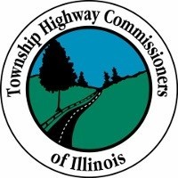
A Division of Township Officials of Illinois

DUES NOTICE $75.00

Enclosed please find dues in the amount of $75.00 for 2023 for the Highway Commissioner’s position for the Township or Road District listed below. If a new appointment or election causes a change in the officeholder, the newly appointed Highway Commissioner shall be fully paid for the Township Road District or Unit Road District shown below.

Name:

County:

Township:

Address:

City/State/Zip:

Office Phone Number: | Home Phone Number:
Cell Phone Number: | Work Phone Number:
Fax Number: E-Mail Address:

Note: These are divisional dues for you as a Highway Commissioner/Road District Commissioner and not to be confused with the T.O.I. dues paid by your Township Supervisor.

Please make checks payable to: Township Highway Commissioners of Illinois
Make any necessary corrections and return this form with your $75.00 Dues Payment to:
Township Highway Commissioners of Illinois
Alice Reed, P.O. Box 114, Blue Mound, IL 62513

For questions call: Craig Smith, Dekalb Township Highway Department, 815-758-5658
Or Alice Reed 217-972-3039

